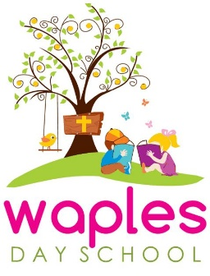
Registration for 2023-24 School Year
Registration will not be accepted until both completed application and registration fees are turned in. Please note that Annual Registration/Building Fees are non-refundable.

Early Registration Fee-Current Students or Siblings/Church Members
(Jan 30-Feb 17)-$175.00 ($125.00 plus $50.00 Building Fee)

Early Registration Fee-Public
(Feb 18-May 12)-$200.00 ($150.00 plus $50.00 Building Fee)

Registration Fee-General
(May 13 and on)-$225.00 ($175.00 plus $50.00 Building Fee)

Waples Day School Tuition
2023-2024 School Year

3 Days/Week (2 & 3 year olds)
AM Program (8:30-11:30)-$2340/year ($260/month for 9 months)
Extended Day (8:30-2:30)-$3330/year ($370/month for 9 months)

5 Days/Week (3 & 4 year olds)
AM Program (8:30-11:30)-$2970/year ($330/month for 9 months)
Extended Day (8:30-2:30)-$4230/year ($470/month for 9 months)

